Installing JAGS

Description of JAGS information
https://mcmc-jags.sourceforge.io/

- Download the desired JAGS executable file (JAGS-3.4.0.exe). To do this, visit the source forge site maintained by Martyn Plummer (author of JAGS) at
https://sourceforge.net/projects/mcmc-jags/files/
Select “Download Latest Version” button or the JAGS file folder, the release of JAGS you wish to install (4.x, 3.x, etc), the platform you’ll be running JAGS on (Windows, Mac, Linux), and finally the version of the release you want (JAGS 4.3.0.exe).
- Run the executable file
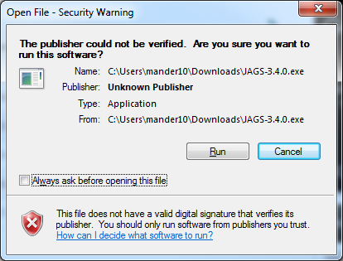
- Leave defaults selected and complete the installation.

